1. 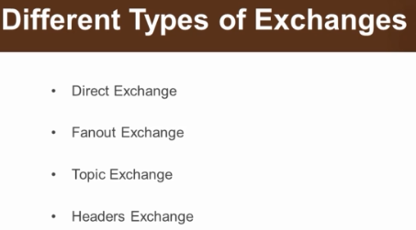
2. Each of these exchanges has its own way of working and its own way of routing a message to a queue.   
   It all depends on the binding b/w exchange and queue.